CAPACITI | Course 4: System Administration and IT Infrastructure Services
Basic Server Setup Practical (Windows IIS Server)

Student Information
Name: Londiwe Nxele
Programme: IT Support
Institution: CAPACITI
Course: System Administration and IT Infrastructure Services

1. Introduction
This practical activity is part of Course 4 and focuses on building fundamental system administration knowledge. The task required setting up a local web server using Microsoft Internet Information Services (IIS), checking that it works correctly, and explaining the basic infrastructure services involved.

2. Server Environment
Operating System: Windows 10 / Windows Server
Web Server: Internet Information Services (IIS)
Server Role: Local Web Server
Root Directory: C:\inetpub\wwwroot

3. IIS Installation and Configuration
IIS was enabled through the Windows Features settings. After installation, the default website was set to load a custom HTML page stored inside the wwwroot folder. The service was then checked to ensure the web server was operating properly.

4. Folder Structure
The main IIS directory contains the website files organised as shown below:
wwwroot
index.html

5. Screenshot Evidence
Screenshot 1: IIS installed and configured in IIS Manager.
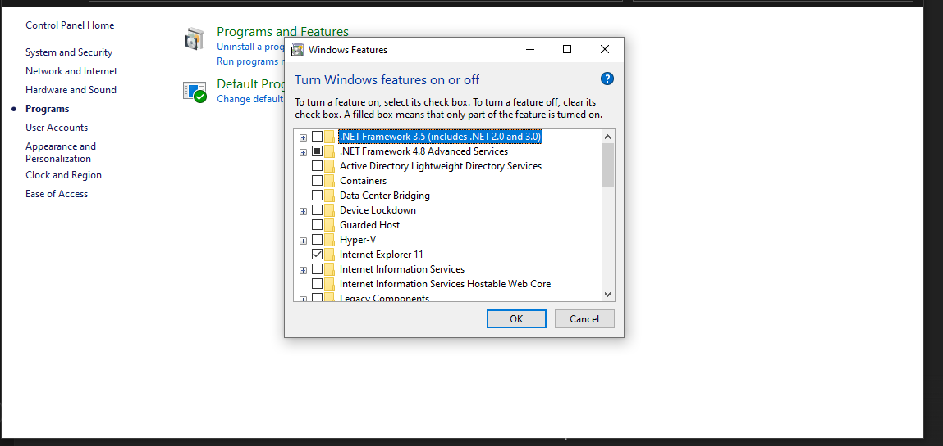
Screenshot 2: IIS Manager confirming the web server is running.
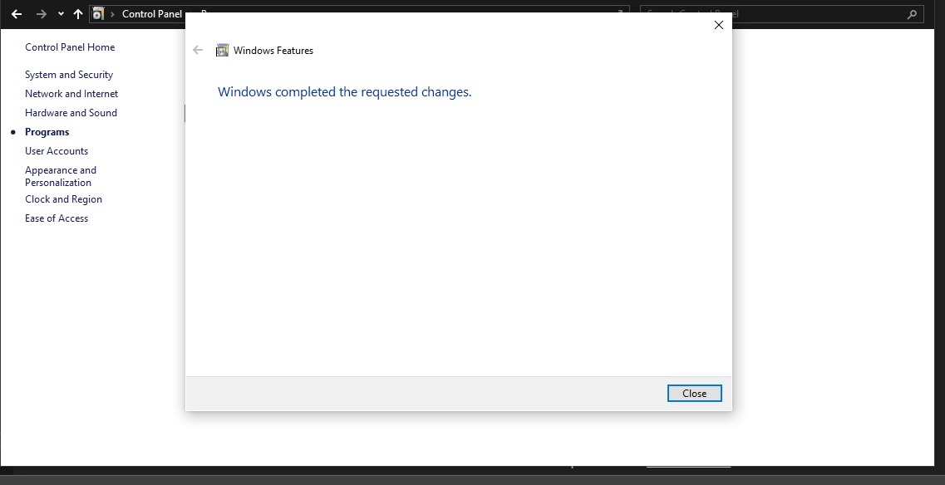

Screenshot 3: Web browser displaying the local IIS website.
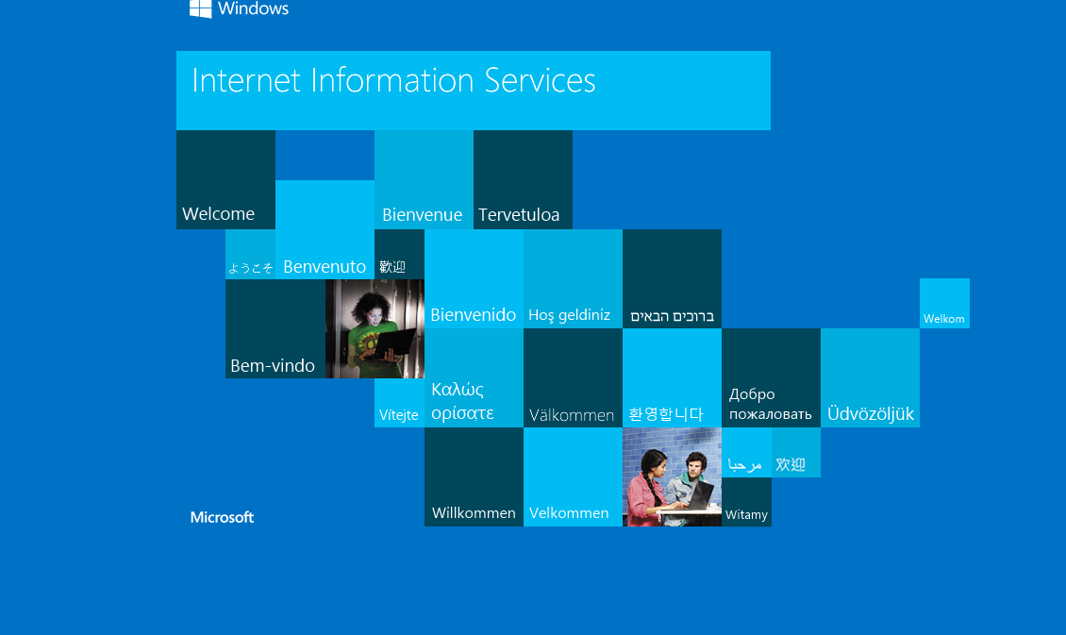
Screenshot 4: wwwroot folder showing the index.html file.
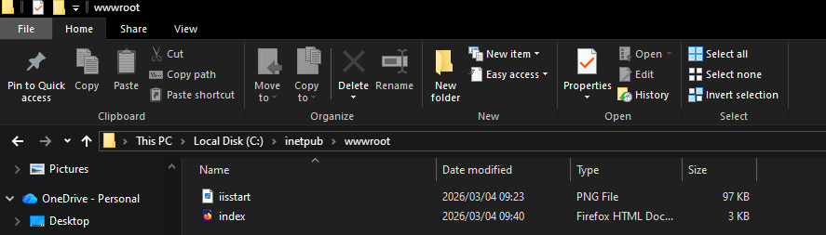
Screenshot 5: HTML source code used to create the page.
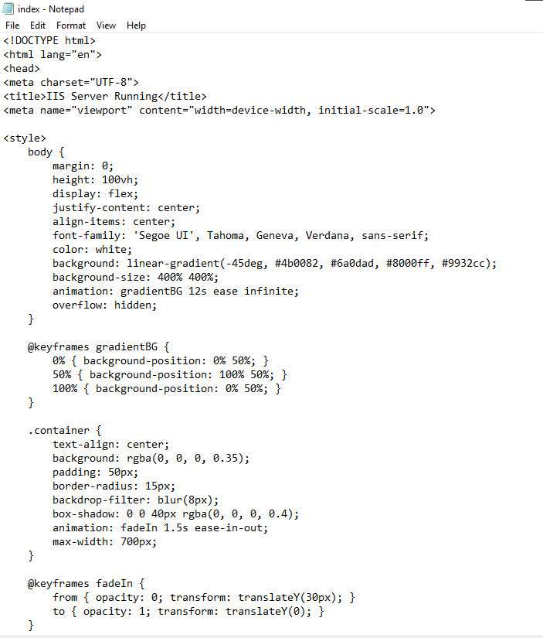
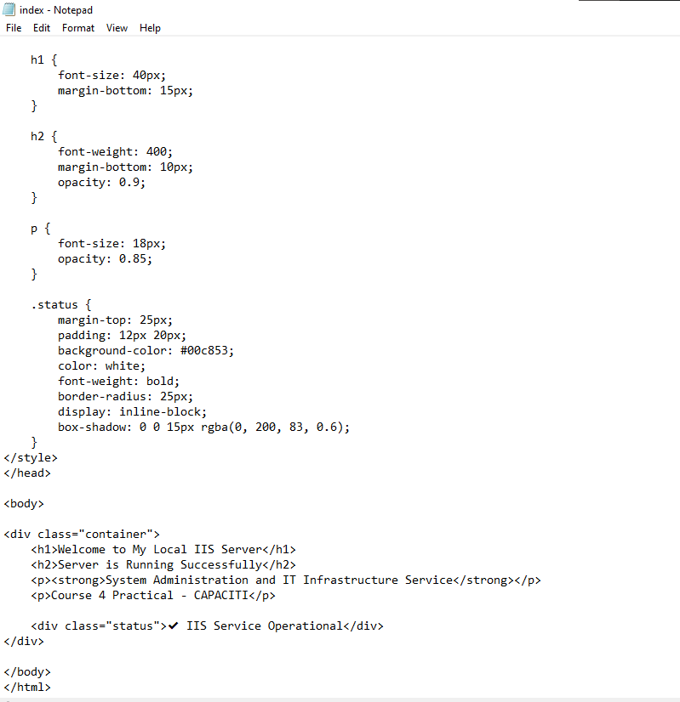
Screenshot 6 (Bonus): Default IIS welcome page.
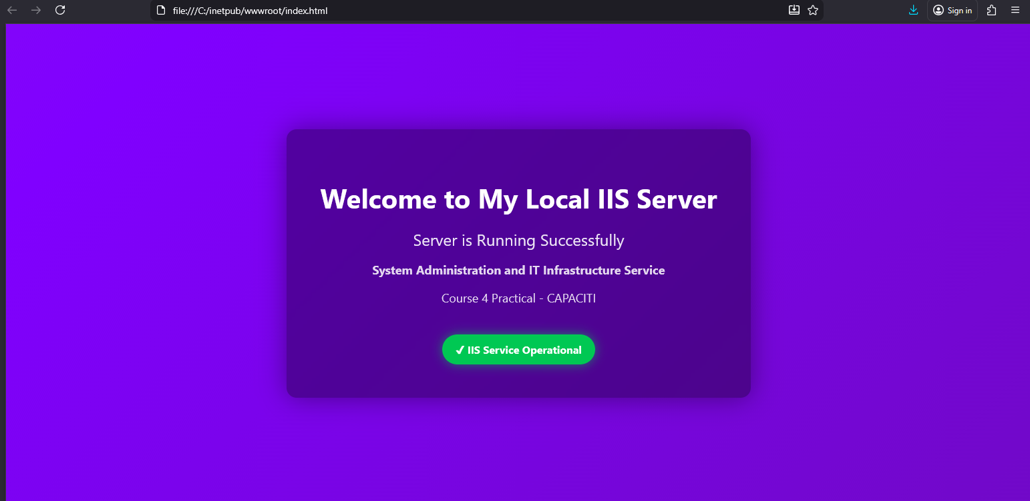

6. Services Explanation
IIS Web Server: Responsible for hosting websites and delivering pages to users over HTTP or HTTPS.
DNS (Domain Name System): Converts names such as localhost into IP addresses so systems can locate servers.
DHCP (Dynamic Host Configuration Protocol): Automatically assigns IP addresses and other network settings to devices.

7. Conclusion
This exercise demonstrated how to install, configure, and test a local IIS web server. It also reinforced understanding of server roles, directory structures, and important supporting network services used in IT environments.

